**Network Architecture Diagram Tool Tutorial**

**For**

**Network Infrastructure Services Utility**

**Prepared by**

**Aayush Patel, Ryan Scott, Ricky Resendes, and Dean Smith**

**12/4/2021**

**1. Tutorial Overview** 3

1.1 Program Overview 3

1.2 Program Usage 3

**2. Starting the Process** 4

2.1 How to setup the backend

2.2 How to setup the frontend

2.3 How to run the first time 6

**3. Continuous Functionality** 6

3.1 Rerun and update

3.2 How to visualize the updates 8

# **Tutorial Overview**

## **Program Overview**

The Network Architecture Diagram Tool was created for the NUWC staff to help them view what devices are currently in use. The tool is displayed in a webpage and currently allows the user to rerun the program in the command line to provide an update to the webpage. However in future tutorials, this update will either be automatic, or through a button press on the webpage.

This tutorial will go over how to set up the backend and frontend, and will show how to start the first run through, as well as continuous run throughs for updating.It will then explain how to process the information through the visual webpage and to understand what is being displayed.

* 1. **Program Usage**

Currently the user simply enters commands into the command line for the initial startup, as well as for the reruns, however the final product will be automatic or have user updates through a button on the diagram. The program will be available to run 24/7 and will not require a restart.

# **Starting the Process**

## **2.1 How to setup the backend**

Step 1: Download MVP.zip onto your computer. This should be located in your Downloads Folder in the File Explorer.

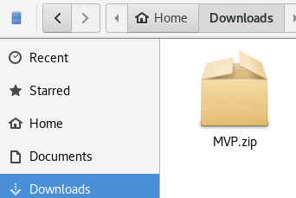

Step 2: Move MVP.zip to where you want to have the program installed. I will move the zip file into my Documents Folder for this tutorial.

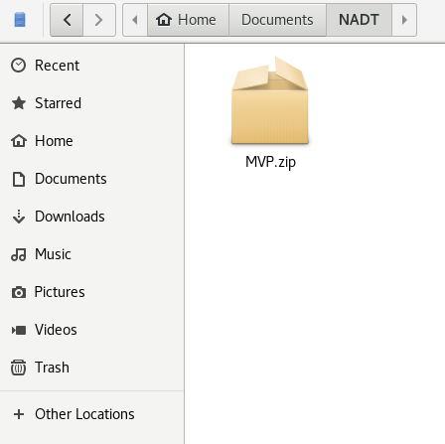

Step 3: Right click the .zip file and press “Extract Here”. You should see a folder named “MVP”.

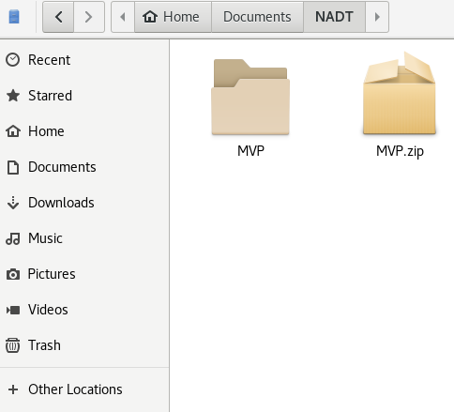

## **2.2 How to setup the frontend**

Step 1: Download and launch VSCode

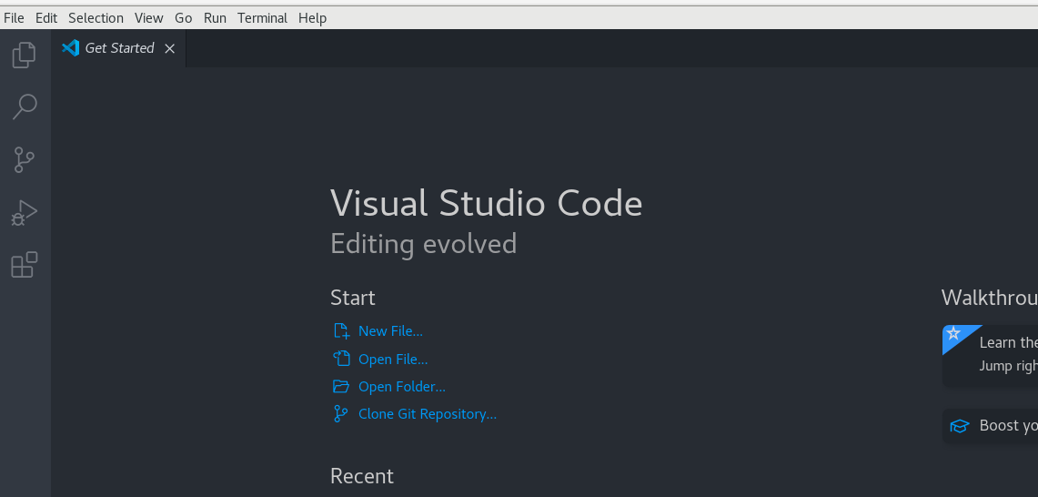

Step 2: Make sure Live Server Extension is installed

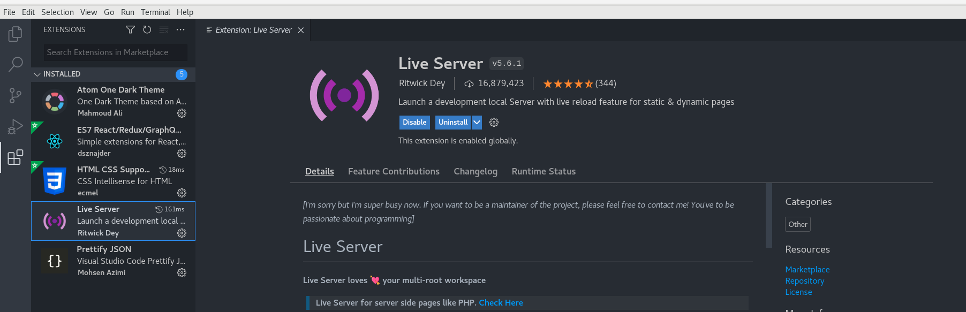

Step 3: On the top left, press “File” -> “Open Folder” and then select the MVP folder

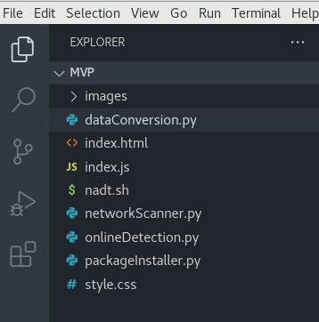

You should see this in the explorer

Step 4: On the bottom right, press “Go Live”



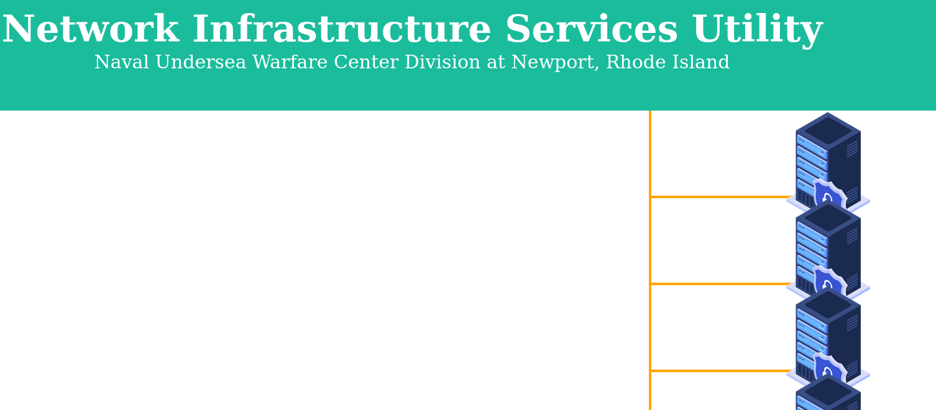

A webpage with the GUI should show up

## **2.3 How to run the first time**

## Step 1: Open the “MVP” Folder and then right click in white space and press “Open Terminal”

## 

Step 2: In the terminal, type “./nadt.sh” and press enter

Step 3: Following the terminal for package installations

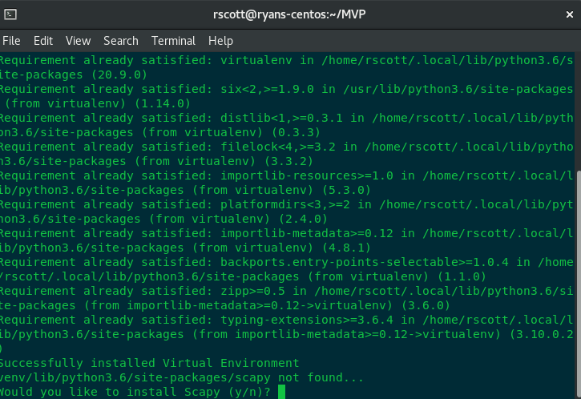

**Make sure to enter ‘y’, Scapy is required for the script to run**

Step 4: Enter in the default gateway IP of your internet along with the range, mine is 10.0.0.1/24

The range in most cases should always be /24 so once you find the default gateway of your wireless connection (or wired, even better), add /24 to the end of it.



Step 5: Check the gui after pressing enter. You should see devices pop up after a successful execution!

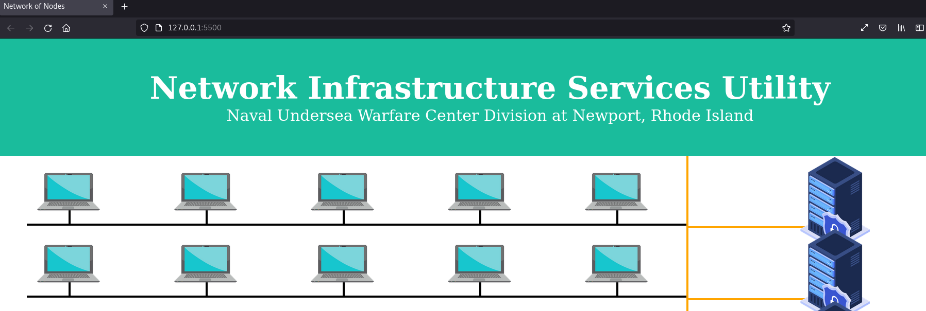

# **Continuous Functionality**

## **3.1 Rerun and Update**

To re-run the application and update the application, re-run the scripts in the order they are listen in Section 2.3

## 

## **3.2 How to Visualize the Updates**

Upon bringing the web page back up it should automatically update to show all the detected devices. Detected devices that are clicked will show a green bubble to show that they are online. Devices that are not detected on a repeat scan will appear as blue after being clicked.